先来先服务FCFS和短作业优先SJF进程调度算法
程序代码：
#include<iostream>
#include<iomanip>
#define Number 5
using namespace std;
void main()
{
int n;
int daoda[Number],fuwu[Number],i;
cout<<"请依次输入各个进程的到达时间并以空格间隔:";
for(i=0;i<Number;i++)
{
cin>>daoda[i];
}
cout<<"请依次输入各个进程的服务时间，并以空格间隔:";
for(i=0;i<Number;i++)
{
cin>>fuwu[i];
}
cout<<"请输入n=1选择FCFS或者n=2选择SJF或者n=3同时调用FCFS和SJF,n=";
cin>>n;
while(n<1||n>3){
cout<<"输入的n有误，请重新输入n，n=";
cin>>n;
}
struct statedd //声明结构
{
bool doneF,doneS;
int daoda,fuwu;
float wancheng,zhouzhuan,daiquan,wan,zhou,dai;
};
statedd process[Number];//声明结构变量，这里为数组

int timeflyF=0,timeflyS=0;//定义两个类似于秒表的变量
int j,k,l,nextproF,nextproS;
// 获取数据
for(i=0;i<Number;i++)
{
process[i].doneF = false;
process[i].doneS = false;
process[i].wancheng = 0;
process[i].zhouzhuan = 0;
process[i].daiquan = 0;
process[i].wan = 0;
process[i].zhou = 0;
process[i].dai =0;
process[i].daoda = daoda[i];
process[i].fuwu = fuwu[i];
}
// 获取最先到达的进程下标first
int first=0;
l=first;
for(i=1;i<Number;i++)
{
if(daoda[first]>daoda[i])
first=i;
}
process[first].doneF=true;
process[first].doneS=true;
process[first].wancheng = process[first].fuwu + process[first].daoda;
process[first].wan = process[first].fuwu + process[first].daoda;
timeflyF += process[first].daoda+process[first].fuwu;
timeflyS += process[first].daoda+process[first].fuwu;

// 接下去到达的进程
//*************************************************************
// fcfs ********************************************************
for(j=1;j<Number;j++)
{
nextproF = Number+1;
for(k =0 ; k<Number; k++ )
{
if( !process[k].doneF )
{
if( process[k].daoda <= timeflyF ) // 到达
{
if( nextproF ==Number+1)
nextproF = k;
else
{
if( process[nextproF].daoda > process[k].daoda )
nextproF = k; //获取到达时刻最先的进程
}//else
}//if2
}//if1
}//for
// 处理
process[nextproF].wancheng = process[nextproF].fuwu + timeflyF;
timeflyF += process[nextproF].fuwu;
process[nextproF].doneF=true;
} // circle2
// SJF **********************************************
for(j=1;j<Number;j++)
{
nextproS = Number+1;
for(k=0 ; k<Number; k++ )
{
if(!process[k].doneS)
{
if( process[k].daoda <= timeflyS ) // 到达
{
if( nextproS ==Number+1 )
nextproS = k;
else
{
if( process[nextproS].fuwu > process[k].fuwu )
nextproS = k; //获取服务时间最小的进程
}//else
}//if2
}//if1
}//for
// 处理
process[nextproS].wan = process[nextproS].fuwu + timeflyS;
timeflyS += process[nextproS].fuwu;
process[nextproS].doneS=true;
} // circle2

//****************************************************************

float Fz=0,Fdq=0,Sz=0,Sdq=0;//
for(i=0;i<Number;i++)
{ //----------------------------------------------------
process[i].zhouzhuan=process[i].wancheng-process[i].daoda;
Fz += process[i].zhouzhuan;
process[i].daiquan=process[i].zhouzhuan/process[i].fuwu;
Fdq += process[i].daiquan;
//----------------------------------------------------
process[i].zhou=process[i].wan-process[i].daoda;
Sz += process[i].zhou;
process[i].dai=process[i].zhou/process[i].fuwu;
Sdq += process[i].dai;
}

//=========================输出==================================
//-------------------------------------------------------------------
if(n==1||n==3){
cout<<"\t"<<endl;
cout<<"FCFS:"<<endl;
for(i=0;i<Number;i++)
{

if(i<1)
{
cout<<"时刻"<<l<<":进程"<<i+1<<"在运行"<<endl;
}
else
{
cout<<"时刻"<<process[i-1].wancheng<<":进程"<<i+1<<"在运行"<<endl;
}
}
cout<<setw(10)<<"进程ID"<<" ";
cout<<setw(10)<<"完成时间"<<" ";
cout<<setw(10)<<"周转时间"<<" ";
cout<<setw(10)<<"带权周转时间"<<" "<<endl;
for(i=0;i<Number;i++)
{
cout<<setw(10)<<i+1<<" ";
cout<<setw(10)<<setiosflags(ios::fixed)<<setprecision(2)<<process[i].wancheng<<" ";
cout<<setw(10)<<setiosflags(ios::fixed)<<setprecision(2)<<process[i].zhouzhuan<<" ";
cout<<setw(10)<<setiosflags(ios::fixed)<<setprecision(2)<<process[i].daiquan<<" "<<endl;
}
cout<<"平均周转时间为： "<<setiosflags(ios::fixed)<<setprecision(2)<<Fz/Number<<endl;
cout<<"平均带权周转时间为："<<setiosflags(ios::fixed)<<setprecision(2)<<Fdq/Number<<endl;
}
//-------------------------------------------------------------------
if(n==2||n==3){
cout<<"\t"<<endl;
cout<<"SJF:"<<endl;
for(i=0;i<Number;i++)
{

if(i<1)
{
cout<<"时刻"<<l<<":进程"<<i+1<<"在运行"<<endl;
}
else
{
cout<<"时刻"<<process[i-1].wan<<":进程"<<i+1<<"在运行"<<endl;
}
}
cout<<setw(10)<<"进程ID"<<" ";
cout<<setw(10)<<"完成时间"<<" ";
cout<<setw(10)<<"周转时间"<<" ";
cout<<setw(10)<<"带权周转时间"<<" "<<endl;
for(i=0;i<Number;i++)
{
cout<<setw(10)<<i+1<<" ";
cout<<setw(10)<<setiosflags(ios::fixed)<<setprecision(2)<<process[i].wan<<" ";
cout<<setw(10)<<setiosflags(ios::fixed)<<setprecision(2)<<process[i].zhou<<" ";
cout<<setw(10)<<setiosflags(ios::fixed)<<setprecision(2)<<process[i].dai<<" "<<endl;
}
cout<<"平均周转时间为： "<<setiosflags(ios::fixed)<<setprecision(2)<<Sz/Number<<endl;
cout<<"平均带权周转时间为："<<setiosflags(ios::fixed)<<setprecision(2)<<Sdq/Number<<endl;
cout<<"\t"<<endl;
}
}

实例截图：
五个进程，到达时间分别为0,1,3,4,6
服务时间分别为5,7,3,8,2
设置选择量n，
当n=1时，选择FCFS
当n=2时，选择SJF
当n=3时，同时分别调用FCFS和SJF
n不为1或2或3时提示错误，重新输入n；

1-FCFS 算法
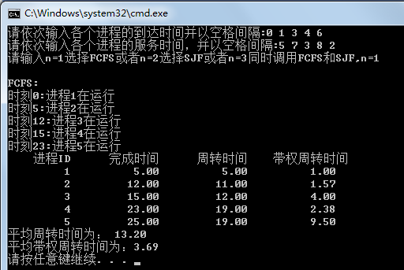

2-SJF算法
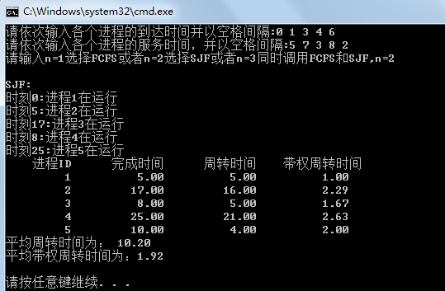
3同时调用FCFS和SJF
